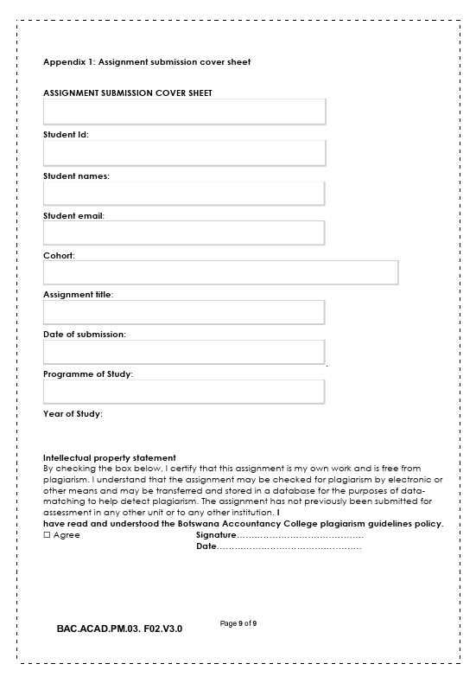WEB SPECIFICATIONS
22/05/2026
Year 1
Computer systems engineering
22/05/2026
WMD Assignment
Cse25-280 https:/github.com/TopsMolah/cse25-280-WMD-Assignment https:/github.com/TopsMolah/cse25-280-WMD-Assignment
Cse25-280@thuto.bac.ac.bw
Tlotso Ofile Pearl Molamoledi
Cse25-280 https:/github.com/TopsMolah/cse25-280-WMD-Assignment https:/github.com/TopsMolah/cse25-280-WMD-Assignment

1.Purpose
The aim of this TLOTSO website is to inform people about diseases related to menstruation in an easy and understandable manner. There are people, especially teenagers and young adults, who do not possess enough information about menstruation due to various reasons. This website aims to break the barrier by providing information about diseases such as Endometriosis and Polycystic Ovary Syndrome in a simple and easy manner that can be understood by anyone.

Moreover, the aim of this website is to increase awareness among people and seek medical assistance at the right time by helping them understand the symptoms of diseases such as Dysmenorrhea and Amenorrhea. By providing information on how to prevent diseases and maintain a healthy lifestyle, the website aims to empower people to manage their health and overcome fear and confusion related to diseases such as Dysmenorrhea and Amenorrhea.

Target Audience (Demographics & Technical Aptitude)
- Teenagers (13-19 years)
- Young Adults, especially females
- Students studying biology or health-related subjects
Demographics:
- Age: 13-30 years
- Education level: From secondary school to early stages of university
- Location: General/global audience
Technical Aptitude:
- Basic computer and smartphone skills
- Familiarity with accessing websites and use of search tools
- Limited knowledge of medical terminology
c. Type of Website
This will be an educational and informational website. It will contain:
- Health education
- Awareness of diseases related to menstruation
- Providing guidance and information

2. Information Design & Taxonomy
a. Information Architecture
Home Page
- Introduction to Menstrual Health
- Overview of diseases related to menstruation
Diseases Page
- Endometriosis
- Polycystic Ovary Syndrome
- Dysmenorrhea
- Menorrhagia
- Amenorrhea
Symptoms Page
- Common Symptoms
- Warning Signs
- Prevention & Care
- Hygiene Tips
- Diet and lifestyle
Resources
- FAQs
- Articles
- Contact Page
- Contact Form
- Help Information
b. Navigation Paths
- Top navigation bar for all main pages
- Dropdown menu under "Diseases"
- Internal links for related pages
- Footer navigation for quick access
c. Taxonomy (Content Organization)
- Main Category: Menstrual Health
- Subcategory: Diseases
- Subcategory: Hormonal Disorders
- Subcategory: Pain-related Disorders
- Subcategory: Bleeding Disorders
- Subcategory: Causes
- Subcategory: Symptom
- Subcategory: Treatment
- Subcategory: Prevention

3. Page Template Design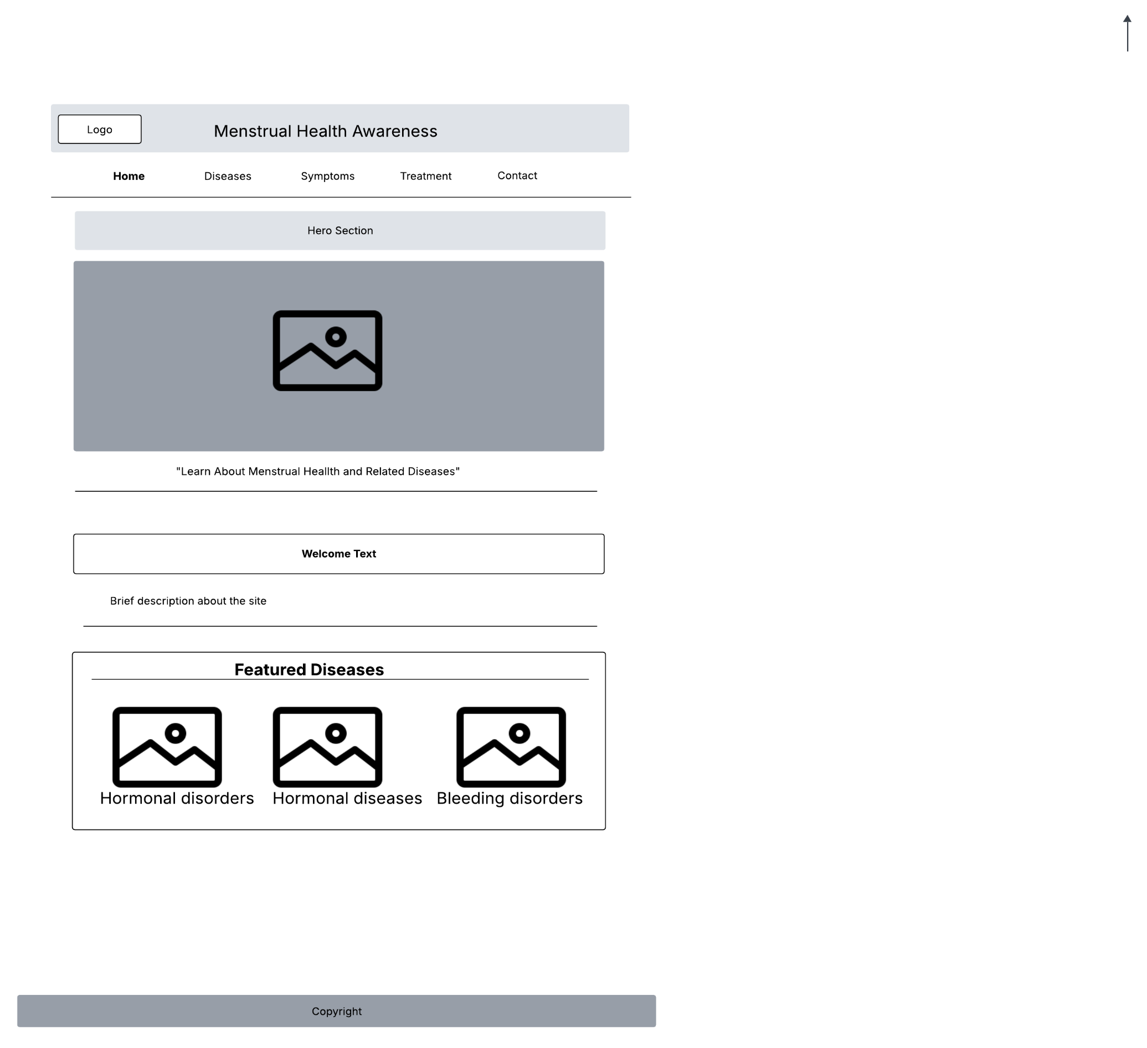

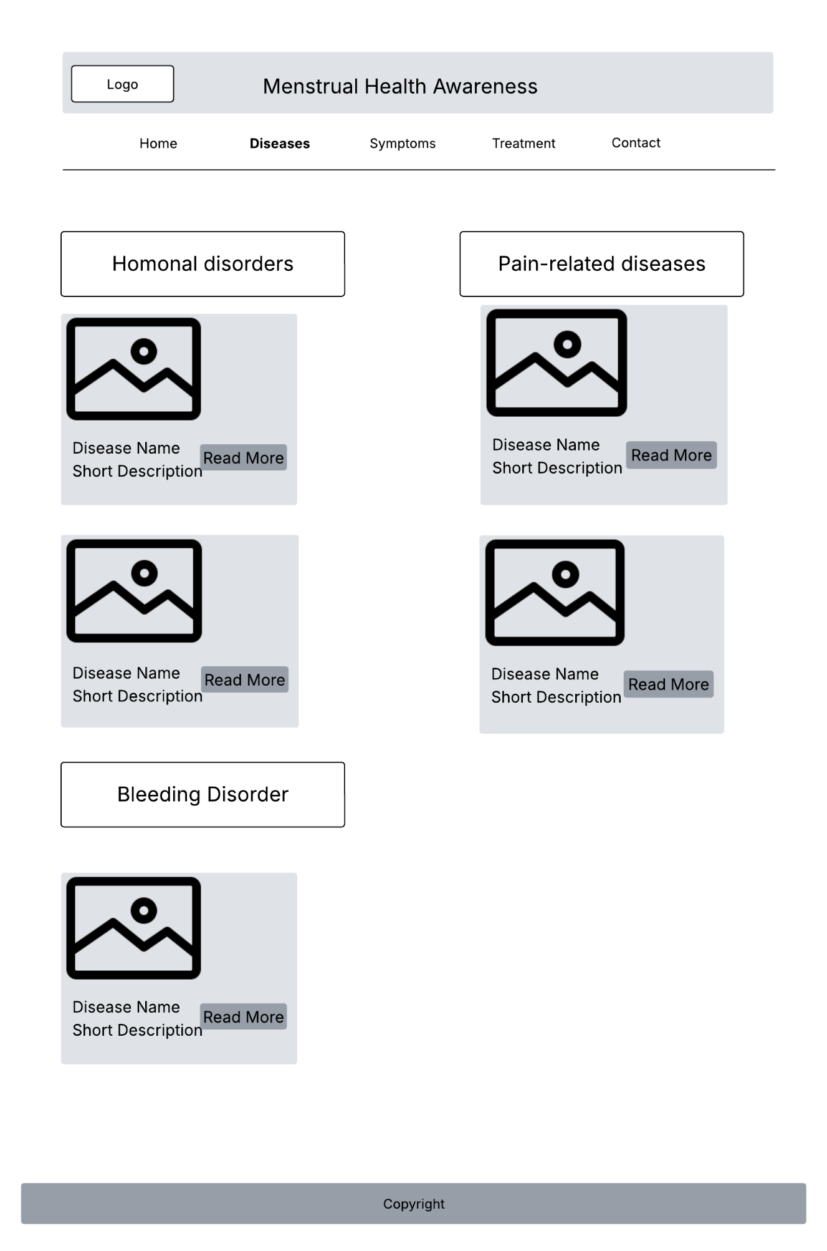
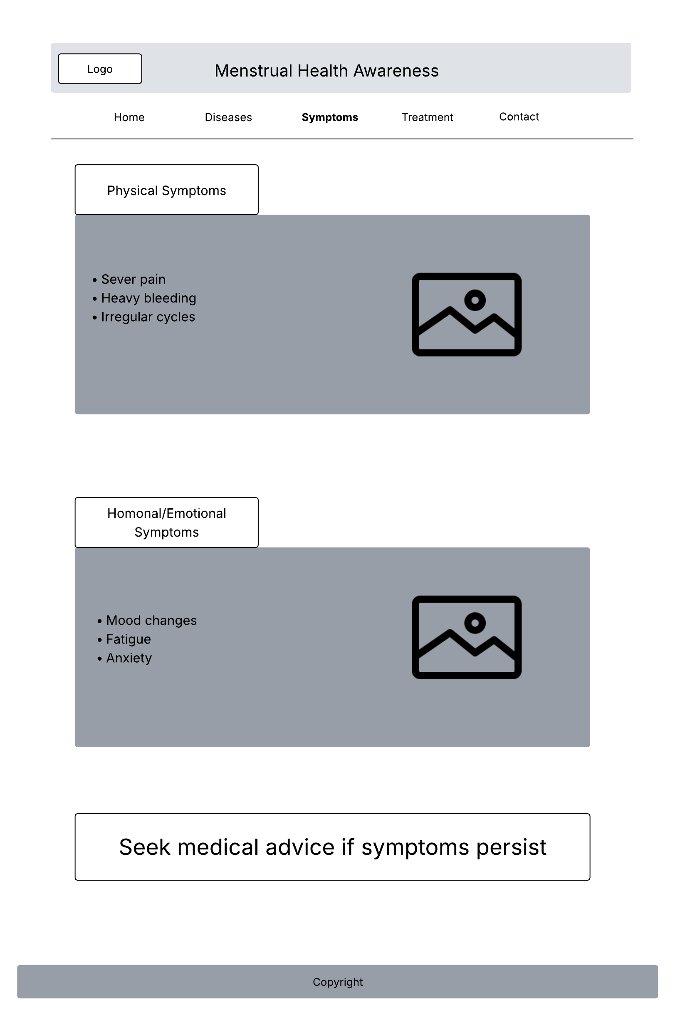
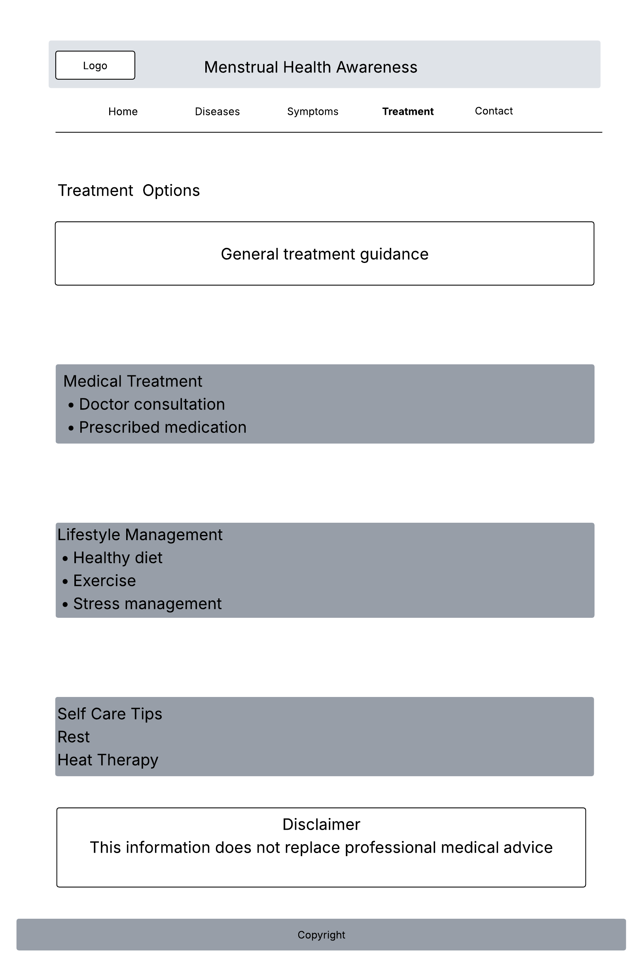

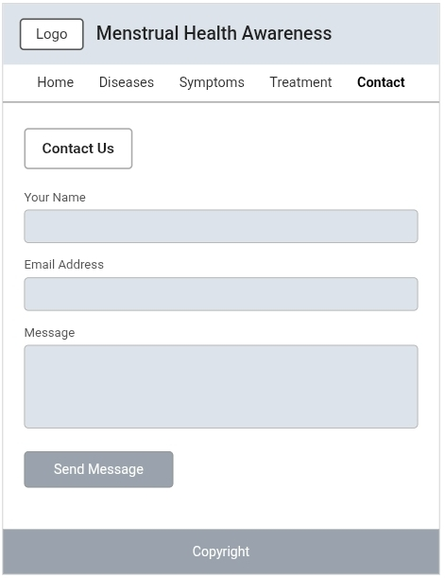
3. Information Design & Taxonomy
a. Information Architecture
Home Page
- Introduction to Menstrual Health
- Overview of diseases related to menstruation
Diseases Page
- Endometriosis
- Polycystic Ovary Syndrome
- Dysmenorrhea
- Menorrhagia
- Amenorrhea
Symptoms Page
- Common Symptoms
- Warning Signs
- Prevention & Care
- Hygiene Tips
- Diet and lifestyle
Resources
- Contact Form
b. Navigation Paths
- Top navigation bar for all main pages
- Dropdown menu under "Diseases"
- Internal links for related pages
- Footer navigation for quick access
c. Taxonomy (Content Organization)
- Main Category: Menstrual Health
- Subcategory: Diseases
- Subcategory: Hormonal Disorders
- Subcategory: Pain-related Disorders
- Subcategory: Bleeding Disorders
- Subcategory: Causes
- Subcategory: Symptom
- Subcategory: Treatment

4. Technical Brief
a. Technologies Used
- HTML - Structure of the website
- CSS - Style and layout of the website
- JavaScript - Interaction of the website
- Bootstrap - Responsive design of the website

Software Tools
- Visual Studio Code (code editor)
- GitHub (repository hosting)
- GitHub Pages (website publishing)
- Browser (Microsoft Edge for testing)
- GitHub Desktop (publish website pages)
- GitHub Pages (deploy and publish the live website)
- Lucidchart (wireframes)

External resources
- All the Read More Buttons on the Disease page link to Mao Clinic articles for credible medical information: Mayo Clinic
- Icons
Hardware requirements
- Laptop or computer
- Smartphone
- Internet connection

f. Justification of the Software Tools
The tools chosen for the project are appropriate since they are simple and sufficient for a project of this nature. They are also commonly used and meet the needs of a student project.

5. Quality Assurance
Browser Compatibility Testing
Browser | Version | Result | Feedback
Google Chrome | Latest | Pass | All pages render correctly
Microsoft Edge | Latest | Pass | Layout and navigation work correctly
Mozilla Firefox | Latest | Pass | CSS Grid and Flexbox supported
Mobile Chrome | Latest | Pass | Res[pensive on mobile screen

Mobile Device Tests
- Android smartphone (HP laptop via dev tools mobile simulator)
- Test remains readable without horizontal scrolling on screens 360em and above
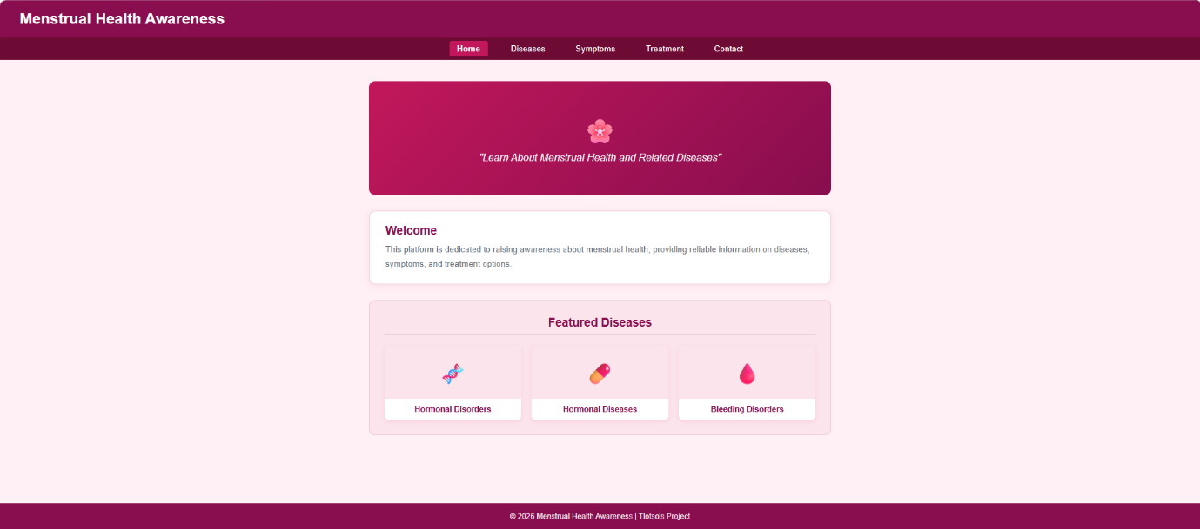
Functional Tests
- Navigation links: All 5 navigate to the correct pages
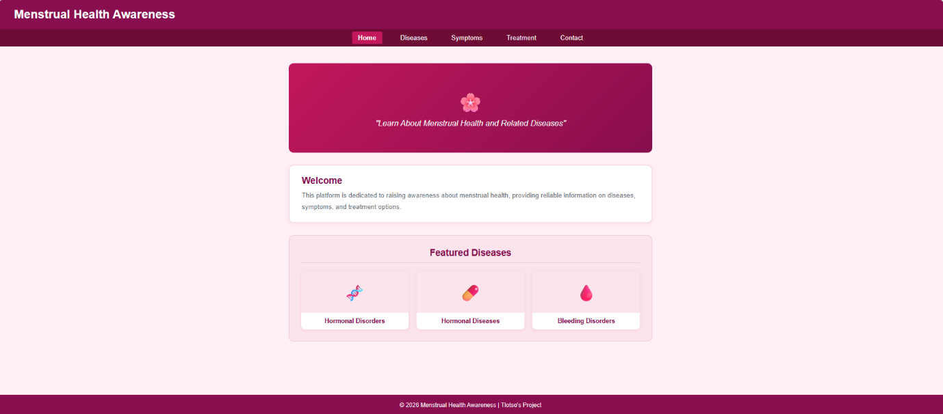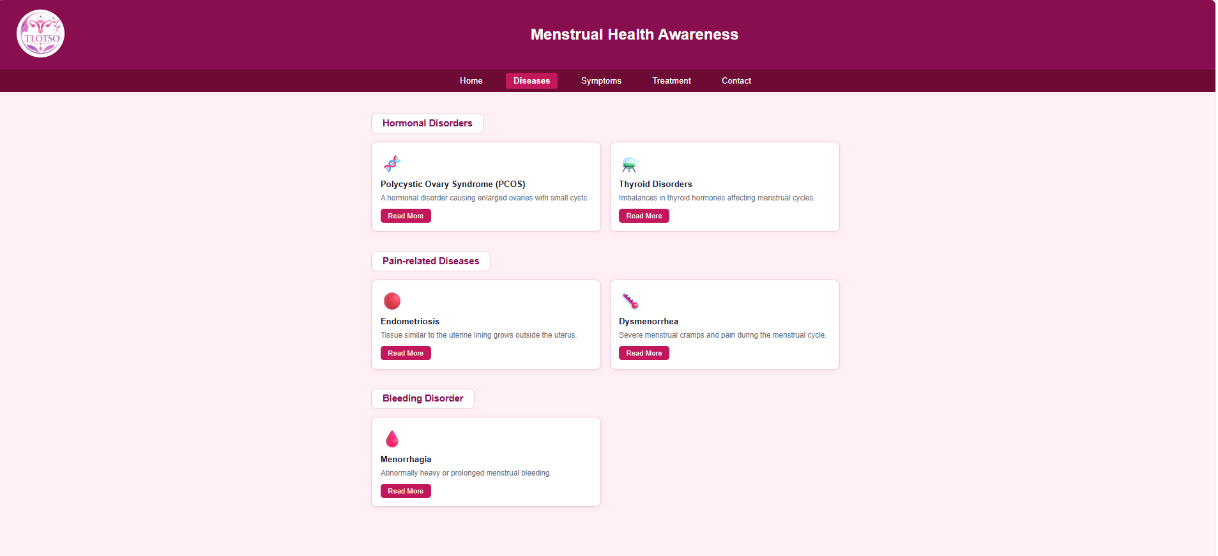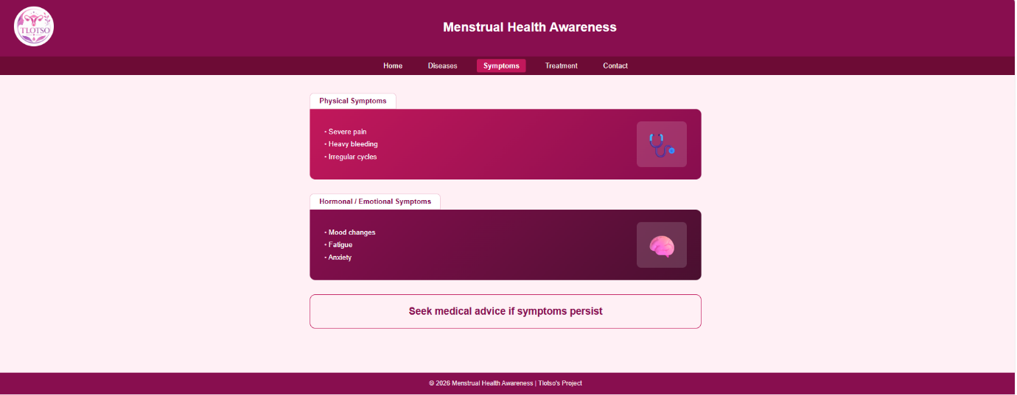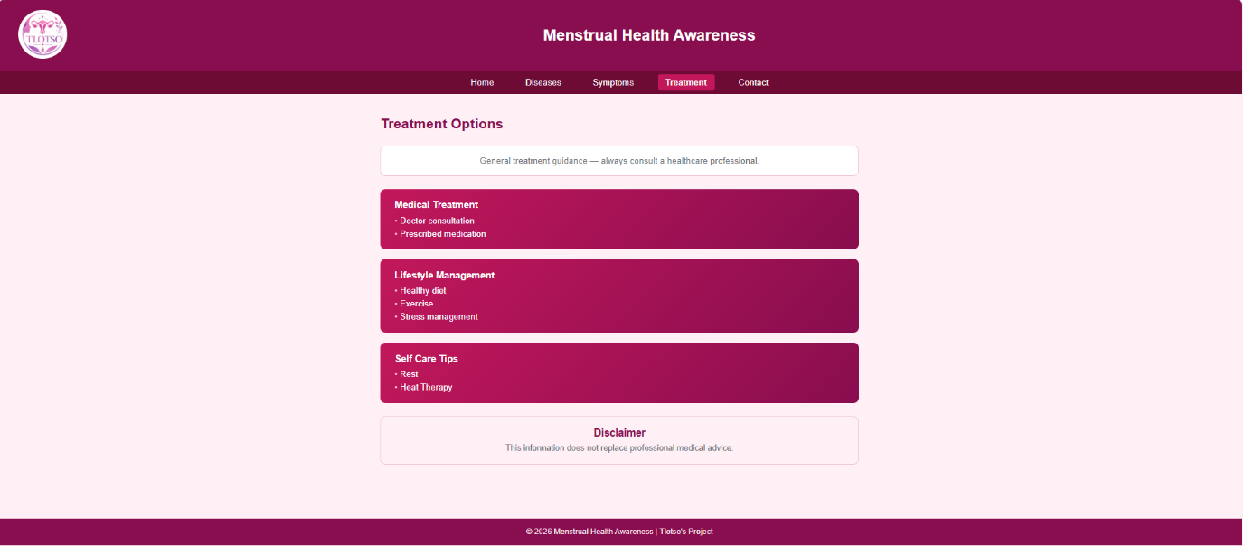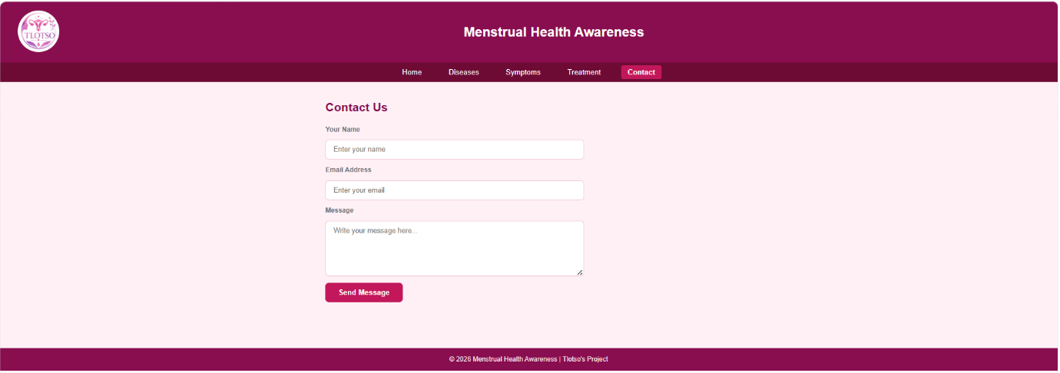
- Active nav highlight: Active pages are highlighted in bold
- Read More buttons: All Read More buttons lead to Mayo Clinic URL’s in a new tab
(sample example)
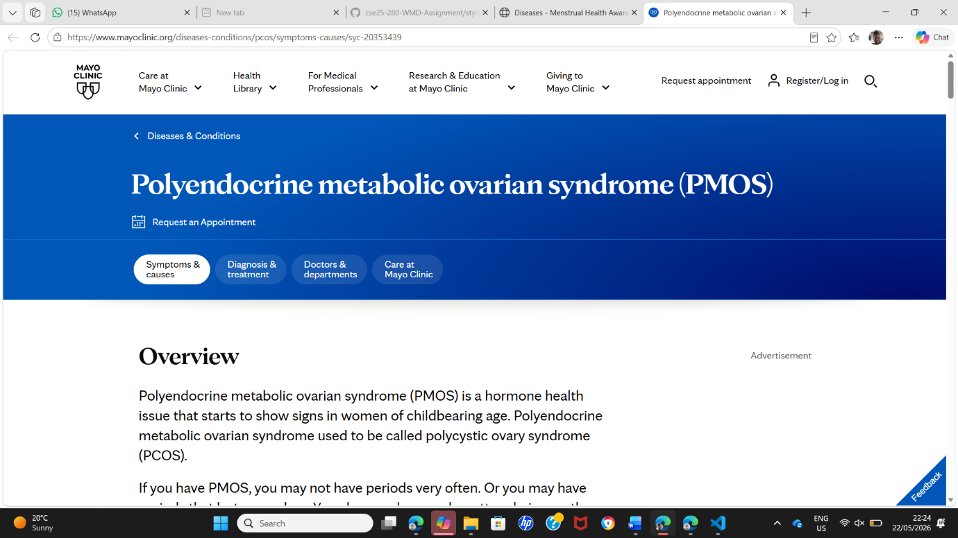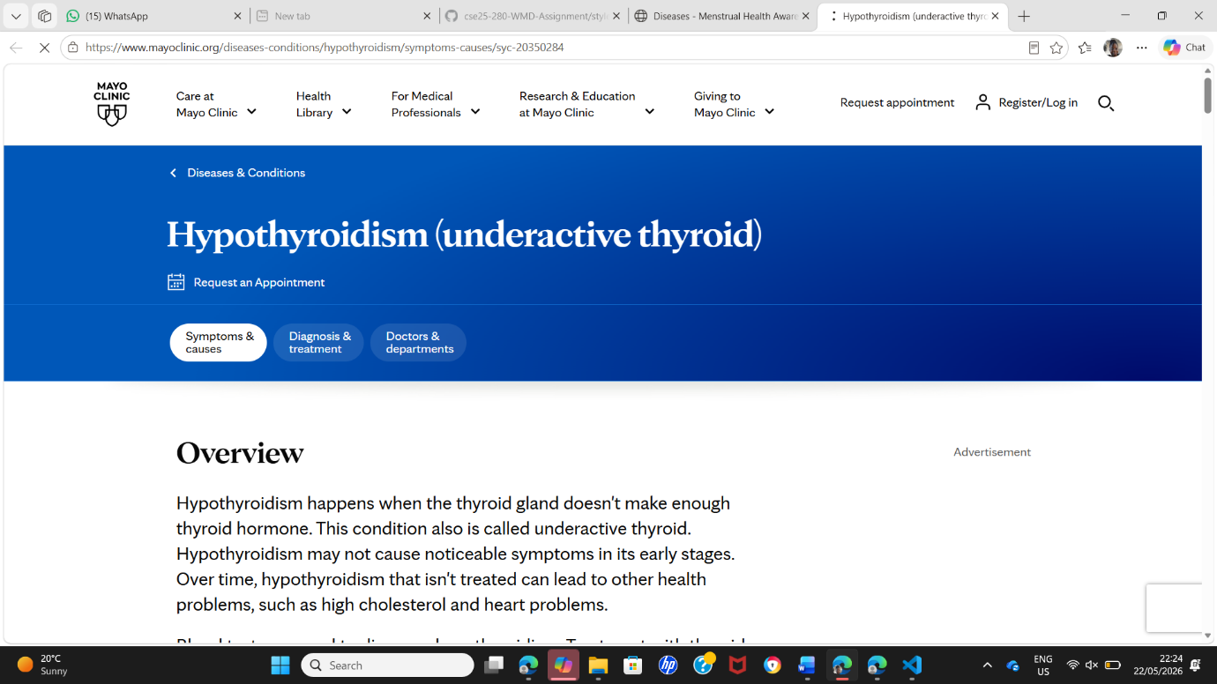
- Contact form: Fields accept input; 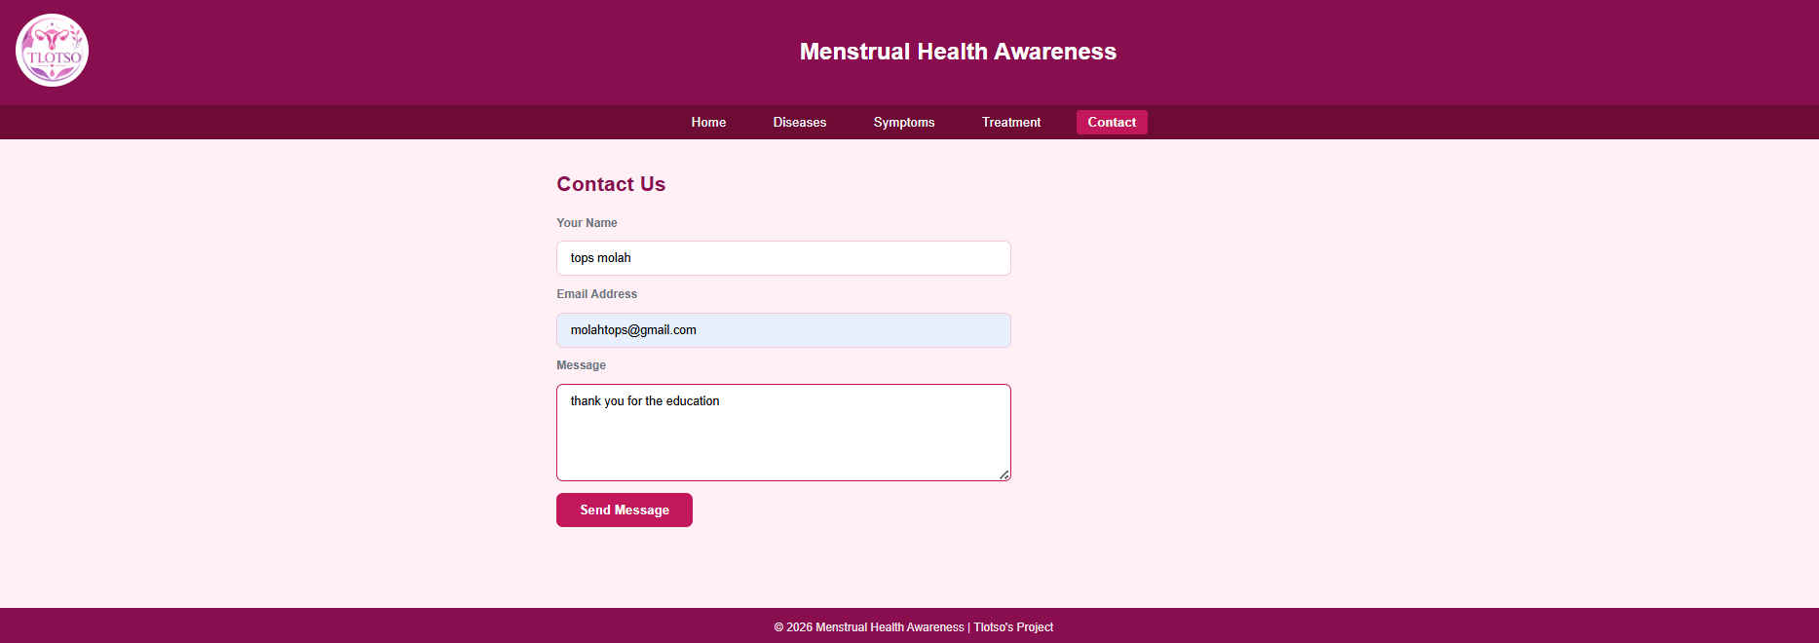
Logo display: Logo renders correctly in all pages

6. Publishing and promotion
- Hosted on GitHub Pages
- Repository name:https:/github.com/TopsMolah/cse25-280-WMD-Assignment-
- Live URL: https:/topsmolah.github.io/cse25-280-WMD-Assignment-/

GitHub commands used
- Git add
- Git init
- https:/github.com/TopsMolah/cse25-280-WMD-Assignment

Promotion
- Sharing the link via WhatsApp for a wide reach

7. Future Developments/Recommend
Further improvement to the website can be done using the following future developments:

- User Accounts – For individualized services
- Symptom checker system – To check symptoms
- Chatbot – For general health queries
- Videos – Educational videos and tutorials
- Multi-Language Support – For wider range of people
- Search Feature – To search easily
- Accessibility – Make site accessible to disabled
- Links to health facilities and specialists – To get direct access to health specialists

Conclusion
The TLOTSO website seeks to equip users with reliable information on diseases associated with menstruation using an interactive, easy-to-use, and aesthetically pleasing website. The website will play a significant role in raising more awareness on menstrual health diseases.

